MedMorph Mortality Reporting Use Case

Description
The purpose of the use case is to identify mortality data that will be extracted from EHRs using FHIR. This information will be sent to a system called the Electronic Death Registration System that is hosted at the jurisdictional level. This use case will help define how EHR data can be used in automated data collection, thereby reducing burden for the healthcare provider and improving the timeliness and quality of data for public health reporting to the state and national vital records offices. This use case is part of a larger initiative to modernize the National Vital Statistics Surveillance System.

Problem Statement
As the diagram shows below, the data mortality flow is a complex ecosystem that involves multiple systems, processes and data providers that feed into the flow.
Starting from the left a medical certifier provides medical information and health history that includes cause of death. This medical history information may be contained within various systems which may include an electronic health record system, toxicology labs, or a Medical examiner or coroners case management system. Demographic and background information is provided by funeral home directors after consulting with family members. This is then sent on to a state’s death registration system. The state then forwards the death record to NCHS. There is bidirectional flow of coded cause of death and coded race and ethnicity between the states registers’ office and NCHS. The mortality data is used to generate national reports, data is also provided to the centralized database of death record information known as the national death index, and surveillance and public and restricted use data are also generated.
The current process involves a combination of manual and unstandardized electronic processes that are not interoperable. They are also prone to human errors, creates bottle necks in the work flow, is cumbersome and time consuming. This compromises the quality and timeliness of the data.
FHIR can provide a huge improvement in the overall efficiency by grabbing data from multiple sources based on the patient’s identifying information and is a key component of the NVSS modernization effort. This diagram provides an overview of what jurisdictions and NCHS are currently working with FHIR based interoperability.

A large percentage of death certificates are certified manually by physicians using paper-based approaches which compromises the timeliness and accuracy of mortality data
- Duplicate data entry between EHR and Electronic Death Registration System (EDRS)
- Having to log into multiple systems/sources to get information needed to certify the cause and manner of death for deaths- cumbersome and time-consuming process.

Health Record Systems
Funeral Home System
Autopsy
Death Scene
Toxicology
Medical History
Demographic
Data
RIP
Physicians
Medical Examiners & Coroners
Funeral Home Directors
Medical
Demographic
State
Registrars
Director of Division of Vital Statistics
National Analyses and Reports
Surveillance, Public Use, and Restricted Data
ME/C Case Management Systems
Death Registration Systems
National Vital Statistics System
EHR

EDRS

State Surveillance, Public Use, and Restricted Data

Goals of the Use Case
- Improve the timeliness in the creation of a death certificate in the EDRS.

Decrease the re-entry of demographic data into the EDRS for the death certificate.

Provide clinical information to physicians for cause and manner of death determination (from the EHR) when certifying the cause and manner of death.

For people who die while in a hospital setting, maintain or improve data accuracy in the death certification process while improving the overall timeliness in reporting mortality data

User Stories
User Story 1:

EHR Environment

Trigger 1: A patient falls ill with COVID-19 and is admitted to a hospital. Sadly, this patient passes away a few weeks after admission. Within minutes of the patient’s death the attending physician pronounces the patient as deceased. The physician then documents the pronouncement of death, including the date/time of death within the EHR. This triggers the collection of an initial inpatient death report containing patient demographics clinical , provider and facility information. The information is compiled into a FHIR bundle and is sent to the respective state vital records electronic death registration system (EDRS). The EDRS sends a report record identifier to the EHR.

Trigger 2: Once the certifying physician (or other provider) completes discharge summary ( in the EHR (anywhere between 2 hours to 2 days after death), the encounter closes in the system. This will change the encounter status to “completed”. This status change triggers a supplemental death report containing select identifying patient variables, and cause of death data (which includes:, significant conditions contributing to death, select clinical notes, discharge summary, health concerns, health problems, lab results, procedures and vital signs) to be sent to the EDRS.
EDRS Environment

The certifying physician logs into the EDRS (immediately following the encounter being completed and/or within 2 days), identifies and pulls up the decedent record. They review prepopulated fields of patient demographic information to confirm that they have the correct record. The physician is aided by the clinical information brought into the record from the supplemental death record and completes the cause and manner of death (and related entries) into EDRS.

Scope of the Use Case

In-Scope
- Deaths that occur within a hospital setting within a FHIR enabled EHR.

Out-of-Scope
- Deaths that occur outside of a hospital
- Provider facing SMART on FHIR app

Use Case Actors
- EHR System: Conforms to the electronic health record (EHR) as defined by the MedMorph project. The EHR System in this use case has the requisite FHIR APIs available.
- Backend FHIR App: Computer application that interacts with the EHR to determine the trigger rules and subscribes to the EHR for topics. The App will interact with the EHR, gather the appropriate data, and then transmit the data to the appropriate systems.
- Jurisdictional electronic death registration system: A FHIR server or service that receives and stores mortality data.

Use Case Abstract Model

The initial death report is triggered (notification message) by the death of a person in an inpatient setting and is sent to an EDRS managed by the jurisdictional Vital Records office. The first death report triggers the creation of decedent record in EDRS. The jurisdictional Vital Records Office expects that the first and last name, gender, date of birth and date of death will be used to establish the identity of the decedent, and these are the information items that are used to define the creation of a new case. If the funeral home director has already created a record for the decedent in the EDRS then it is possible that the information coming from the EHR does not match what has been entered by the funeral home: these errors are especially frequent for name. Therefore, EDRS managers have defined manual procedures to be followed when near or partial matches occur. The specific details of these procedures are defined locally by the EHR vendor and hospital.

Once the funeral director has determined that the death record is complete in the EDRS, they will submit it to the jurisdictional Vital Records Office. Relevant data received by the EDRS are managed by the jurisdictional Vital Records Office and sent to NCHS as a jurisdiction death report. After NCHS processes information received for a death, it will respond by providing coded cause of death and coded race & ethnicity messages to the jurisdictional Vital Records Office. However, the red box highlights the business workflow in scope with MedMorph.

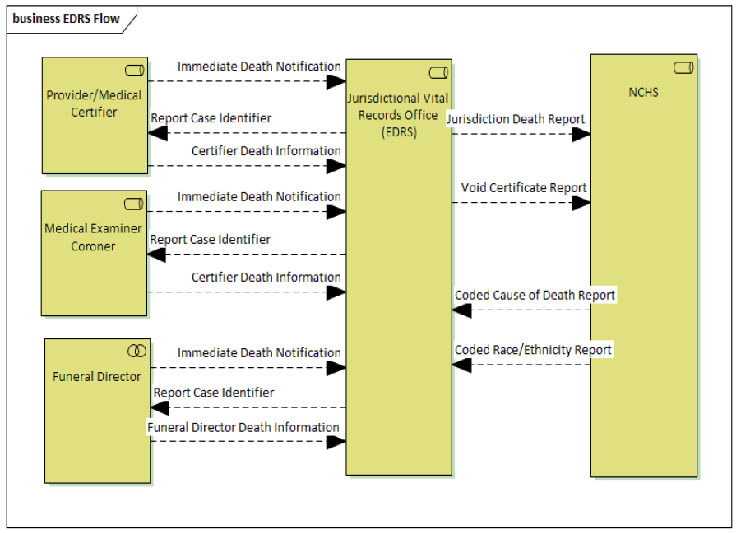

Flow Diagram

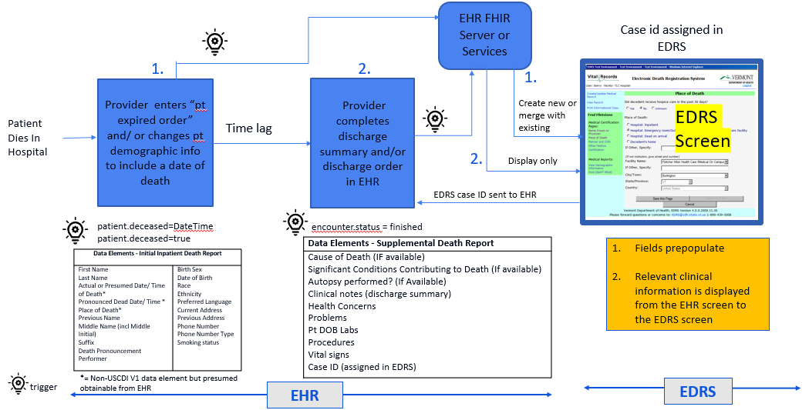

Preconditions
- The EHR and jurisdictional EDRS are FHIR enabled
- Relevant demographics information is captured within EHR to prepopulate EDRS.
- Relevant clinical data is captured within EHR to support cause of death determination that happened within a hospital.

Main Flow

Step | Actor | Role | Activity | Input(s) | Output(s)
1 | EHR System | Notifier | Notify backend services app that death has occurred | Date of death trigger | Notification message
2 | RA Backend services app | Data receiver | Validates that date of death has been created | Initial inpatient death notification | Initial inpatient death notification trigger
2.5 | EDRS | Data receiver | Receives incoming data created in EHR | Initial inpatient death notification | Validated FHIR initial inpatient death report
3 | EHR system | Notifier/Content creator | Notify RA backend services app that encounter is completed | timing and other criteria | Notification message
4 | RA Backend services app | Data extractor | Push data elements to support determination on cause of death to the EDRS | Data Push | FHIR bundle containing the supplemental death report
7 | EDRS | Data Receiver | Receive and validate FHIR bundle with supplemental death report | FHIR bundle | Validated FHIR bundle

Postconditions
- The jurisdictional EDRS received complete FHIR bundles with relevant information for a death certificate.

Alternate Flow
- Medical examiner and corner data flow
- Funeral home director data flow

Activity Diagram

<Illustrates the flow of events and information between the Actors.>

Data Requirements
Below are the data elements that are part of the death certificate

Mortality Data Elements:
Item Id | Death Certificate Data Item | Definition |  | Availability (Always, Maybe, Never) |  | Relationship to notification (I- initial and S- Supplemental) | Source (Manual Entry, API, Transform, PH Investigation)
1 | Decedent's Legal Name |  |  | Maybe |  | I
2 | Sex |  |  | Maybe |  | I
3 | Social Security Number |  |  | Maybe
4 | Age [years, days, or minutes] |  |  | Maybe
5 | Date of Birth |  |  | Maybe |  | I
6 | Birthplace |  |  | Maybe
7 | Residence Address |  |  | Maybe
8 | Ever in the Armed Forces? |  |  | Maybe
9 | Marital Status at Time of Death |  |  | Maybe
10 | SURVIVING SPOUSE’S NAME |  |  | Maybe
11 | Father's Name |  |  | Maybe
12 | Mother's Name Prior to First Marriage |  |  | Maybe
14 | Place of Death
15 | Facility Name
16 | City or Town, state, and zip |  |  | Always
17 | County of Death |  |  | Maybe
18 | Method of Disposition |  |  | Maybe
19 | Place of Disposition |  |  | Maybe
20 | Place of Disposition |  |  | Maybe
22 | Signature of Funeral Service Licensee or Other Agent |  |  | Always
23 | License Number [Funeral Director] |  |  | Always
24 | Date Pronounced Dead |  |  | Always |  | I
25 | Time Pronounced Dead |  |  | Always
26 | Signature of Person Pronouncing Death |  |  | Always
27 | License Number [Person Pronouncing Death] |  |  | Always
28 | Date Signed[by Person Pronouncing Death] |  |  | Always
29 | Actual or Presumed Date of Death |  |  | Always
30 | Actual or Presumed Time of Death |  |  | Always
31 | Was Medical Examiner or Coroner Contacted? |  |  | Always
33 | Was an Autopsy Performed? |  |  | Maybe
34 | Were Autopsy Findings Available to Complete the Cause of Death? |  |  | Maybe
35 | Did Tobacco use contribute to death? |  |  | Always
36 | Pregnancy - If Female |  |  | Maybe
37 | Manner of Death |  |  | Always
38 | Date of Injury |  |  | Maybe
39 | Time of Injury |  |  | Maybe
40 | Place of Injury |  |  | Maybe
41 | Injury at Work? |  |  | Maybe
42 | Location of Injury |  |  | Maybe
43 | Describe How Injury Occurred |  |  | Maybe
44 | If Transportation Injury, specify [the role of the decedent] |  |  | Maybe
44 | If Transportation Injury, specify [the role of the decedent] |  |  | Maybe
45 | Certifier's Role |  |  | Always
47 | Title of Certifier |  |  | Always
48 | License Number [Certifier] |  |  | Always
49 | Date Certified[by Person Completing Cause of Death] |  |  | Always
50 | Date Filed |  |  | Always
51 | Decedent's Education |  |  | Maybe
52 | [is]Decedent of Hispanic Origin? |  |  | Maybe
53 | Decedent's Race |  |  | Maybe
54 | Decedent's Usual Occupation |  |  | Maybe
55 | Kind of Business/Industry |  |  | Maybe
13a | Informant's Name |  |  | Maybe
13b | Relationship to Decedent |  |  | Maybe
13c | Mailing Address [Informant] |  |  | Maybe
21a | Name of Funeral Facility |  |  | Maybe
21b | Address of Funeral Facility |  |  | Maybe
32Ia | Cause of Death |  |  | Always |  | S | Formats could include free text within clinical notes or structured elements
32Ia | Cause of Death |  |  | Always |  | S | Formats could include free text within clinical notes or structured elements
32Ib | Interval onset to death |  |  | Always |  | S | Formats could include free text within clinical notes or structured elements
32II | Other Significant Conditions Contributing to Death |  |  | Maybe |  | S | Formats could include free text within clinical notes or structured elements
32II | Other Significant Conditions Contributing to Death |  |  | Maybe |  | S | Formats could include free text within clinical notes or structured elements
46a | Name of Person Completing Cause of Death |  |  | Always
46b | Address and Zip Code of Person Completing Cause of Death

Policy Considerations
- Varying policies of how states report their death data from EHRs
- Data quality of certifying a death record based on information received from an EHR. State specific data elements.
- Policies related to physician’s workflow for cause of death certification
- Policies related to the use of EHR data for death certification
- Data privacy, security related to the use of patient identifiable EHR data available in the EDRS

Non-Technical Considerations
- SLAs between EHR and EDRS vendors
- Buy in from hospitals and providers
- Entity responsible for bearing the costs (e.g. hospital? EHR vendors? VRO?)
- Data quality and usability of the data
- Comparison of the ‘As is’ and ‘To be’ data flows and if changing the process actually would help <Capture non-technical considerations for the use case to be implemented in the real-world such as performance, SLAs etc.>

Appendices
- Related Use Cases and Links
- References to appropriate documentation
- Modernizing the National Vital Statistics System: https://www.cdc.gov/nchs/nvss/modernization.htm
- Current CI build for HL7 Vital Records Mortality and Morbidity Reporting FHIR Implementation Guide: https://trifolia-fhir.lantanagroup.com/igs/lantana_hapi_r4/vrdr/index.html
- HL7 Version 2.6 Implementation Guide: VRDR Release 1 STU 2
- Tripp Huff et al EMR Reporting of Death from Intermountain HC AMIA Nov 2015
- USCDI: https://www.healthit.gov/isa/us-core-data-interoperability-uscdi
- Terms and definitions
- Electronic Health Record: An electronic health record (EHR) is a real-time, patient-centered records that makes information available instantly and securely to authorized users. While an EHR does contain the medical and treatment histories of patients, an EHR system is built to go beyond standard clinical data collected in a provider’s provision of care location and can be inclusive of a broader view of a patient’s care. EHRs are a vital part of health IT and can:
  - Contain a patient’s medical history, diagnoses, medications, treatment plans, immunization dates, allergies, radiology images, and laboratory and test results
  - Allow access to evidence-based tools that providers can use to make decisions about a patient’s care
  - Automate and streamline provider workflow
(Adapted from - Source: https://www.healthit.gov/faq/what-electronic-health-record-ehr)
- Topics for Technical Work Groups
- Reference Architecture

