Making EHR Data More Available for Research and Public Health (MedMorph)

Hepatitis C Use Case

CDC Contract Number 47QTCA19D0013
Hepatitis C Use Case Table of Contents
Description 3
Problem Statement 3
Goals of the Use Case 4
Scope of the Use Case 4
In-Scope 4
Out-of-Scope 4
User Stories 4
User Story 1: Uncomplicated Adult Male - HCV Care Cascade 4
HCV Testing and Diagnosis 4
Hepatitis C Pretreatment Assessment 5
Treatment 5
Cured 5
User Story 2: Pregnant Woman and Exposed Infant – HCV Care Cascade 6
Diagnostic Flow 6
Delivery Flow 6
Post-Partum Treatment Flow for Mother 7
Testing, Diagnosis and Treatment Flow for Infant 7
Use Case Actors 8
Preconditions 8
Use Case Flows and Diagrams 9
Hepatitis C electronic Initial Case Reporting (eICR) 9
eICR Abstract Model 9
eICR Main Flow 10
eICR Activity Diagram 11
eICR Sequence Diagram 11
Hepatitis C Reporting 12
Reporting Abstract Model 12
Reporting Main Flow 13
Reporting Activity Diagram 14
Reporting Sequence Diagram 14
Postconditions 15
Alternate Flow(s) 15
Data Requirements 16
Policy Considerations 18
Non-Technical Considerations 18
Appendices 18
A. Related Use Cases and Links 18
B. References to Appropriate Documentation 18
C. Terms and Definitions 18
D. Topics for Technical Work Groups 19

Table of Figures
Figure 1. HCV Care Cascade 3
Figure 2. Hepatitis C eICR Abstract Model 9
Figure 3. Hepatitis C eICR Activity Diagram 11
Figure 4. Hepatitis C eICR Sequence Diagram 12
Figure 5. Hepatitis C Reporting Abstract Model 13
Figure 6. Hepatitis C Reporting Activity Diagram 14
Figure 7. Hepatitis C Reporting Sequence Diagram 15

List of Tables
Table 1. Hepatitis C electronic Initial Case Report (eICR) Main Flow 11
Table 2. Hepatitis C Chronic Reporting Main Flow 14
Table 3. Hepatitis C Data Elements 18

MedMorph Hepatitis C Use Case

Description
The purpose of the use case is to demonstrate how public health programs and research stakeholders can leverage and build upon current investments in electronic case reporting (eCR) to improve the availability of data that advance national public health priorities, in this case, eliminating hepatitis C as a public health threat in the United States.

Problem Statement
Effective public health and research action depends on access to timely, relevant, and complete data. Unfortunately, the availability and quality of data to public health, particularly data captured in EHRs, remains limited: current data systems and exchange standards are siloed, and existing interoperability standards are administratively cumbersome, underutilized, or otherwise limited in application and scope. Many state and local programs do not have the data necessary to assess hepatitis C disease burden and its distribution in their communities, let alone monitor trends in key epidemiological parameters and health outcomes, like those captured in the HCV care cascade (as shown in Figure 1 below). In the absence of such situational awareness, public health programs lack the information necessary to efficiently and effectively direct public health action and population health research activities. The public health consequences of this current state are illustrated by, but certainly not unique to, hepatitis C surveillance.

Figure 1. HCV Care Cascade

Goals of the Use Case
- Develop a use case to ensure the MedMorph architecture supports the electronic reporting of comprehensive hepatitis C data by health care providers and health systems to public health, researchers, and other potential users, such as clinical registries and quality reporting entities
- Principles to help guide this goal include:
  - Optimize access to hepatitis C data that are already captured within the EHR
  - Reduce the implementation and reporting burden on providers and health systems by automating electronic reporting and minimizing duplicative data demands whenever possible
  - Align with existing legal requirements

Scope of the Use Case

In-Scope
- Identify and report current HCV infection to public health and through bi-directional communication send information back to health care systems
- Improving data flow and reporting/sharing at the following jurisdictional “level(s)” should be prioritized under this use case:
- Among local stakeholders
- Local -> State
- State -> National

Out-of-Scope
- Data captured outside the EHR and communicated directly to registries or public health
  - This includes electronic reporting from laboratories directly to public health, as well as data sent from pharmacy systems directly to clinical registries
- Policies of the clinical care setting to collect consent for data sharing

User Stories
User stories describe real-world observation including actors, events, systems, trigger events and actions. We have included two user stories to describe the MedMorph hepatitis C use case.

User Story 1: Uncomplicated Adult Male - HCV Care Cascade

HCV Testing and Diagnosis
Patient X visits his primary care doctor, Dr. Y, for a non-emergent matter, and during the visit, Dr. Y notices that the EHR has flagged Patient X as being eligible/due for a hepatitis C test. Dr. Y places/approves an order for FDA approved hepatitis C antibody test, with automatic reflex to an FDA-approved Nucleic Acid Testing (NAT) assay intended for detection of hepatitis C virus (HCV) RNA to confirm the diagnosis. An onsite lab tech draws a blood specimen from Patient X via venipuncture and sends the specimen to an offsite lab.

The lab performs the recommended testing sequence. In this case, the anti-HCV test is reactive, so an FDA-approved NAT assay for HCV RNA is performed on the same specimen (reflex testing). This, too, is reactive, indicating that Patient X is currently infected with HCV. The lab sends results electronically to Dr. Y. Receipt of any HCV antibody and/or HCV RNA test result in the EHR automatically triggers an initial electronic case report (eICR) to public health, as well as any clinical registry with which Dr. Y’s practice is affiliated.

Hepatitis C Pretreatment Assessment
A member of Dr. Y’s office calls Patient X to schedule a follow up appointment with the doctor to review/discuss test results. During that follow up appointment, Dr. Y orders a transient elastrography test (to evaluate the degree of hepatic fibrosis present); HCV genotype; and a series of lab tests, including complete HBV serology testing, complete blood count (CBC), HIV tests, and a complete metabolic profile including a hepatic function panel (i.e., albumin, total and direct bilirubin, alanine aminotransferase (ALT), aspartate aminotransferase (AST), calculated glomerular filtration rate (eGFR)). The results of these will be used by Dr. Y to inform his recommended HCV treatment strategy. Dr. Y’s office receives the results from these follow up tests.

Depending on registry protocols and state/local reporting requirements (e.g., around acute case reporting), receipt of these pretreatment test results triggers a report (following proper consent protocols) to public health and/or the clinical registry.

Patient X meets with Dr. Y to discuss treatment options. The results, which are shared with Patient X, indicate that there is no liver cirrhosis present and Patient X is infected with genotype 1b.

Treatment
Dr. Y performs a complete medication reconciliation to ascertain any potential drug-drug interactions and learns there is no risk. Dr. Y prescribes a daily fixed-dose combination of ledipasvir (90mg)/sofosbuvir (400mg) for 12 weeks as recommended by AASLD. Patient X’s insurer has a PA process in place for the medication Dr. Y is recommending, so the clinical pharmacist assembles and submits the necessary paperwork. Patient X is called by the case manager in 2 weeks that the medication has been approved and follows up with the next available appointment with the clinical pharmacist. Patient X follows up with the clinical pharmacist and receives counseling about adherence to the medication and picks up the medication and starts to take it.

When the electronic order for the prescription is entered by Dr. Y, it also triggers a report (following proper consent protocols) to public health and the clinical registry with which Dr. Y’s practice is affiliated.

Cured
Patient X follows up with the clinical pharmacist 4 weeks after starting treatment. During each visit, the clinical pharmacist reviews any adverse events and or newly started prescriptions that may pose risk of drug-drug interactions and discusses/reinforces the importance of adherence to the regimen. Patient X follows up every 4 weeks with the clinical pharmacist while being treated. During the 3rd visit, which is the end of treatment visit (12 weeks after starting treatment), the clinical pharmacist orders an HCV RNA test for 3 months later for the post treatment assessment of cure. Patient X goes to the lab 3 months later to be tested and returns to Dr. Y’s office to confirm HCV RNA is undetectable (virologic cure).

Receipt of the HCV RNA test result in the EHR automatically triggers a report (following proper consent protocols) to public health, as well as any clinical registry with which Dr. Y’s practice is affiliated.

User Story 2: Pregnant Woman and Exposed Infant – HCV Care Cascade

Diagnostic Flow
Patient A, a pregnant woman (hereafter, “Mom”), visits her OBGYN, Dr. A, for her initial prenatal care visit. During this visit, Dr. A orders routine prenatal labs, including an FDA-approved hepatitis C antibody test. An onsite lab tech draws a blood specimen from Mom via venipuncture and sends the specimen to an offsite lab.

The lab performs the recommended testing. In this case, the anti-HCV test is reactive, so an FDA-approved NAT assay for HCV RNA is performed on the same specimen (reflex testing). This, too, is reactive, indicating that Mom is currently infected with HCV. The lab sends results electronically to Dr. A. Receipt of any HCV antibody and/or HCV RNA test result in the EHR automatically triggers an initial electronic case report to public health, as well as any clinical registry with which Dr. A’s practice is affiliated.

NOTE: the report triggered should include information indicative of current pregnancy. Ideally, this information would be communicated using emerging standards for representing pregnancy status. Alternatively, and/or additionally, other information in the EHR could be defined as being a reasonably reliable proxy indicator of potential pregnancy and so included in the report if present (e.g., calculated time since last menstrual period, recent prenatal panel test ordered).

Because current HCV treatment regimens are not approved for use during pregnancy, Dr. A does not immediately initiate a referral for treatment.

Delivery Flow
Several months later, Mom goes into labor and arrives at the hospital. Mom’s HCV infection status is communicated to the hospital staff and captured in its EHR (e.g., in the problem list or medical history) so healthcare staff can take necessary additional precautions.

Mom delivers a healthy baby girl (hereafter “Baby”). Data on the delivery and its outcome are captured in the hospital’s EHR. The combination of information indicating a live birth, as well as Mom’s documented HCV infection status, triggers the hospital EHR to send a report (following proper consent protocols) to public health. That report includes information on Mom; her HCV infection status (diagnosis and/or test results and date); and her delivery (delivery date and outcome).

The delivery records are also forwarded to Baby’s pediatrician, Dr. P, where it also triggers a report (following proper consent protocols) to public health that includes information on Baby and Baby’s exposure to HCV (recognized based on Mom’s HCV infection status).

NOTE: the hospital “delivery” and pediatrician “exposure” reports triggered under this flow allow for public health follow up to ensure the exposed infant receives appropriate care. In an ideal world, the “infant” flow outlined further below would itself ensure such follow up care. But reality is often far messier, especially when it comes to communication of data across different institutions and providers for different individuals (mom, baby). Adding these reporting steps better positions public health to help ensure those connections are made—and that providers like the pediatrician know what steps to take when caring for an exposed infant.

Post-Partum Treatment Flow for Mother
Mom has a post-delivery visit with Dr. A at 2 weeks, at which time Dr. A makes a referral for Mom to see Dr. Z, an HCV treatment provider.

At her first appointment with Dr. Z, he orders a transient elastrography test (to evaluate the degree of hepatic fibrosis present); HCV genotype; and a series of lab tests, including complete HBV serology, complete blood count (CBC), HIV tests, and a complete metabolic profile including a hepatic function panel (i.e., albumin, total and direct bilirubin, alanine aminotransferase (ALT), aspartate aminotransferase (AST), calculated glomerular filtration rate (eGFR)). The results of these will be used by Dr. Z to inform his recommended HCV treatment strategy. Dr. Z’s office receives the results from these follow up tests.

Mom has a second appointment with Dr. Z to discuss options. The results, which are shared with Mom, indicate that there is no liver cirrhosis present and Patient X is infected with genotype 1b. Mom indicates that she is breast feeding and would like to continue to do so until Baby is at least 6 months old. Dr. Z and Mom thus decide to defer treatment for several months, until Baby has transitioned to bottle feeding.

Approximately 5 months later, Mom has a follow up visit with Dr. Z. Mom is no longer breast feeding, and she and Dr. Z agree to initiative treatment for her hepatitis C.

From here, the flow for Mom is identical to User Story #1 (treatment and cure).

Testing, Diagnosis and Treatment Flow for Infant
Based on the records he received from the hospital, Dr. P knows that Baby was exposed to HCV. During Baby’s follow-up well child check, Dr. P orders an FDA-approved Nucleic Acid Test (NAT) intended for detection of hepatitis C virus (HCV) RNA. An onsite lab tech draws a blood specimen from Baby and sends the specimen to an offsite lab.

The lab performs the recommended test, and the results are reactive. The lab sends results electronically to Dr. P. Receipt of the HCV RNA test result in the EHR automatically triggers an electronic initial case report to public health.

Dr. P makes a referral for Baby to see Dr. X, a pediatric gastroenterologist. During Baby B’s first visit with Dr. X., Dr. X explains to Mom that it is too early to initiate treatment for Baby—and that there is a possibility that Baby’s viremia will prove transient.

Because HCV DAAs are not approved for use in children as young as Baby, Dr. X does not initiate treatment at this time. Instead, he will continue to monitor Baby’s health until she reaches age 3.

Once Baby is 3 years old, Dr. X will evaluate Baby and make a treatment recommendation.

At this point, the flow for Baby is similar to User Story #1 (treatment and cure).

Use Case Actors
- EHR: An electronic health record (EHR) is a system used in care delivery for patients and captures and stores data about patients and makes the information available instantly and securely to authorized users. While an EHR does contain the medical and treatment histories of patients, an EHR system is built to go beyond standard clinical data collected in a provider’s provision of care location and can be inclusive of a broader view of a patient’s care. EHRs are a vital part of health IT and can:
  - Contain a patient’s medical history, diagnoses, medications, treatment plans, immunization dates, allergies, radiology images, and laboratory and test results
  - Allow access to evidence-based tools that providers can use to make decisions about a patient’s care
  - Automate and streamline provider workflow

A FHIR Enabled EHR is one which exposes FHIR APIs for other systems to interact with the EHR and exchange data. FHIR APIs provide well defined mechanisms to read and write data. The FHIR APIs are protected by an Authorization Server which authenticates and authorizes users or systems prior to accessing the data. The EHR in this use case is a FHIR Enabled EHR.
- Backend Services App: A system that resides within the clinical care setting and performs the reporting functions to public health and/or research registries. The system uses the information supplied by the metadata repository to determine when reporting needs to be done, what data needs to be reported, how the data needs to be reported and to whom the data should be reported. The term “Backend Service” is used to refer to the fact that the system does not require user intervention to perform reporting. The term “App” is used to indicate that it is similar to SMART on FHIR App which can be distributed to clinical care via EHR vendor specified processes. The EHR vendor specified processes are followed to enable the Backend Services App to use the EHR's FHIR APIs to access data. The healthcare organization is the one who is responsible for implementing the Backend Services App within the organization.
- Data/Trust Services: A set of services that can be used to pseudonymize, anonymize, de-identify, hash or re-link data that is submitted to public health and/or research. These Data/Trust services are used as appropriate by the Backend Services App.
- Trusted Third Party: An intermediary organization (e.g., HIE, RCKMS/AIMS Platform) that serves as a conduit to exchange data between healthcare organizations and PHAs. Trusted Third Parties perform the intermediary functions (e.g., applies business logic and informs the Reportability Response) using appropriate authorities and policies.
- Public Health Authority (PHA) Data Store: A FHIR server or service that receives and stores the hepatitis C data.

Preconditions
Preconditions describe the state of the system, from a technical perspective, that must be true before an operation, process, activity, or task can be executed. Preconditions are what needs to be in place before executing the use case flow.

The preconditions for the hepatitis c use case include:
- Data use agreements are in place when needed
- Public Health uses allowed by HIPAA and other statutory authority have been defined and implemented
- All patient encounters required to initiate and move through the care cascade take place (i.e., patient attends) with authorized providers, and requisite steps (e.g., tests ordered; performed; and results received; drug prescribed) are performed and captured in the EHR using approved standards
- Registry and state/local consent protocols are followed when sending supplemental reports for non-reportable conditions
- Provisioning workflows have been established. The provisioning workflow includes activities that publish the various metadata artifacts required to make EHR data available to public health and/or research. These activities include publishing value sets, trigger codes, reporting timing parameters, survey instruments, structures for reporting etc. These artifacts are used subsequently in data collection and reporting workflows.

Use Case Flows and Diagrams
The user stories described two workflows for reporting Hepatitis C diagnosis (eICR) and treatment (reporting). The sections below highlight the abstract model, main flow, activity diagram and sequence diagram for each workflow.

Hepatitis C electronic Initial Case Reporting (eICR)
The electronic Initial Case Report (eICR) is termed “initial” because the report may be the first report made to public health from the clinical provider, containing just enough pertinent data for PHAs to initiate investigation or other appropriate public health activities as necessary.

eICR Abstract Model
Figure 2 below is the Abstract Model that illustrates the actors, activity, and systems involved in the eICR workflow when a patient has been diagnosed with Hepatitis C.
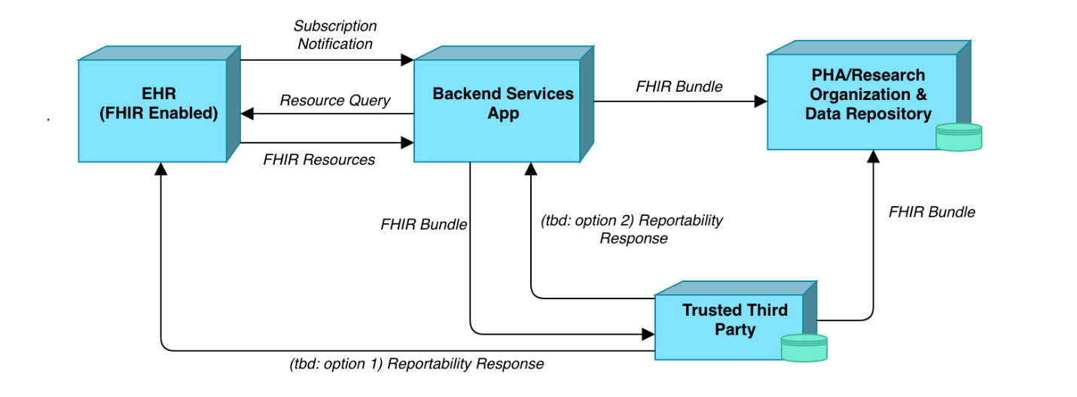
Figure 2. Hepatitis C eICR Abstract Model
The FHIR Enabled EHR sends subscription notifications to the Backend Services App when there has been activity in topics in which the app subscribes to. The Backend Services App then queries the EHR and the EHR returns the appropriate FHIR resources. The Backend Service App receives and validates the resources and compiles them into a FHIR Bundle. The Backend Services App sends the FHIR Bundle to the Trusted Third Party. The Trusted Third Party checks reportability of eICR, generates a Reportability Response RR), and send the RR to the EHR and Backend Services App. The Backend Services App sends the FHIR bundle to the Public Health Authority (PHA).

eICR Main Flow
The table below illustrates each actor, role, activity, input, and output of each step of the Hepatitis C electronic Initial Case Reporting (eICR) workflow.
Step | Actor | Role | Activity | Input(s) | Output(s)
1 | EHR System | Notifier | Notify the Backend Services App that there has been activity in topics the app subscribes to | Trigger codes | Notification message
2 | Backend Services App | Evaluator | Evaluates criteria (and timing if needed to wait on lab results) | Notification message, criteria, rules | Yes/No query decision
3 | Backend Services App | Data Extractor | Query the EHR for case data | Query decision | FHIR queries
4 | EHR System | Query Responder | Return case data | FHIR queries | FHIR resources
5 | Backend Services App | Data Receiver | Receive and validate FHIR resources | FHIR resources | FHIR eICR validated bundle
6 | Backend Services App | Data Sender | Send validated FHIR bundle as eICR to a Trusted Third Party | FHIR eICR validated bundle | FHIR eICR bundle
7 | Trusted Third Party | Data Receiver | Receive and validate FHIR bundle | FHIR eICR bundle | validated FHIR eICR bundle
8 | Trusted Third Party | Evaluator | Confirms reportability of eICR and generates RR | FHIR eICR bundle | Reportability Response (RR)
9 | Trusted Third Party | RR Sender | Transmits RR to EHR System/Backend Services App/PHA | RR | RR
10 | Trusted Third Party | Data Sender | Send FHIR eICR bundle | Validated eICR FHIR bundle | FHIR eICR bundle
11 | EHR System/Backend Services App/PHA | Data Receiver | Receive and process RR | RR | processed RR
12 | PHA | Data Receiver | Receive and validate FHIR eICR bundle | FHIR eICR bundle | validated FHIR eICR bundle
Table 1. Hepatitis C electronic Initial Case Report (eICR) Main Flow

eICR Activity Diagram
Figure 3 below illustrates the flow of events and information between the actors for the Hepatitis C eICR workflow.
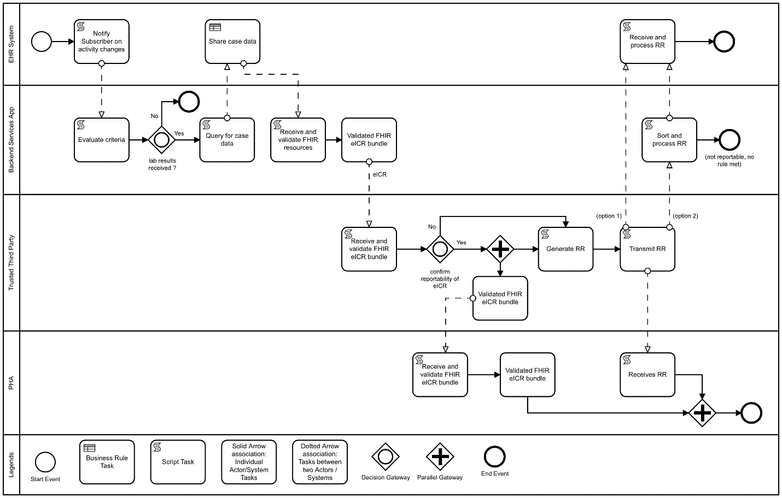
Figure 3. Hepatitis C eICR Activity Diagram

eICR Sequence Diagram
Figure 4 below represents the interactions between actors in the sequential order that they occur in the Hepatitis C eICR workflow.
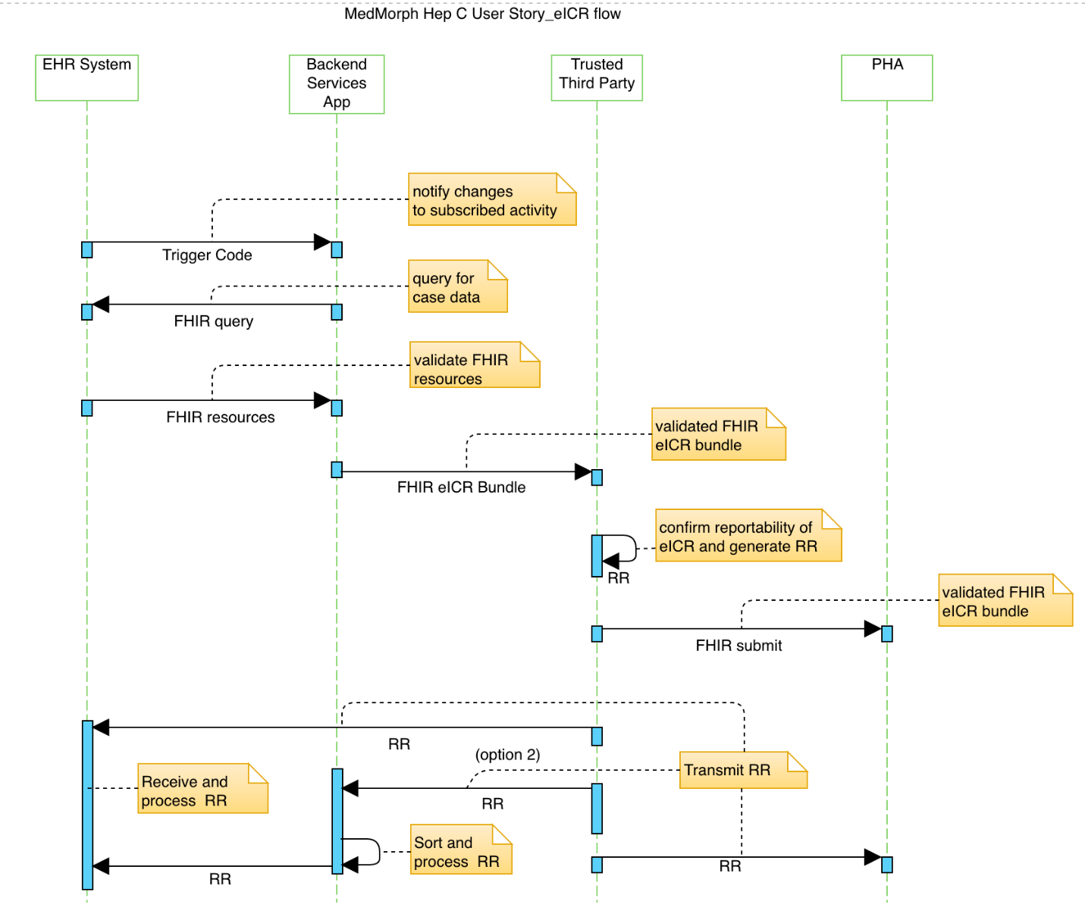
Figure 4. Hepatitis C eICR Sequence Diagram

Hepatitis C Reporting
The reporting workflow is used during the pre-treatment assessment, treatment, and cured stages of the HCV Cure Cascade. The sections below expand on the abstract model, main flow, activity diagram and sequence diagram for the reporting workflow.

Reporting Abstract Model
For the reporting of treatment and follow up of Hepatitis C, use the workflow as illustrated in Figure 5 below.

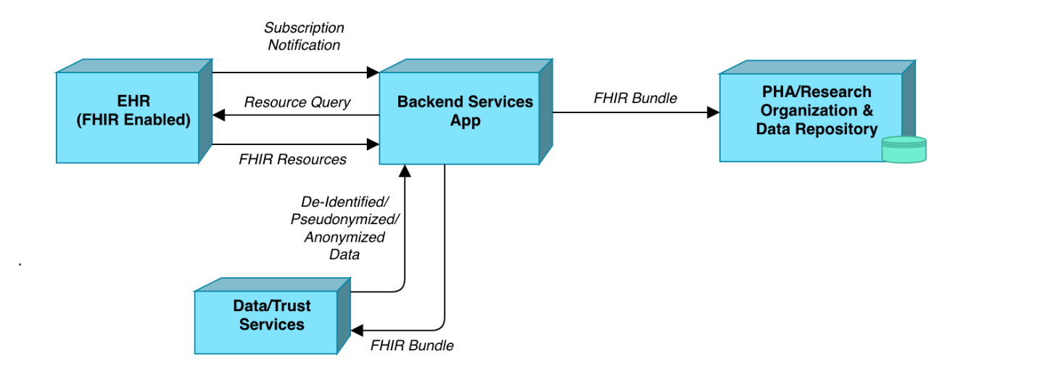
Figure 5. Hepatitis C Reporting Abstract Model

The FHIR Enabled EHR sends subscription notifications to the Backend Services App when there has been activity in topics in which the app subscribes to. The Backend Services App then queries the EHR and the EHR returns the appropriate FHIR resources. The Backend Service App receives and validates the resources and compiles them into a FHIR Bundle. The Backend Services App sends the FHIR Bundle to the Data / Trust Services. The Data/Trust Services sends the deidentified/pseudonymized/anonymized data back to the Backend Services App. The Backend Services App sends the FHIR bundle to the Public Health Authority (PHA).

Reporting Main Flow
Table 2 below illustrates each actor, role, activity, input, and output of each step of the Hepatitis C Reporting workflow.
Step | Actor | Role | Activity | Input(s) | Output(s)
1 | EHR System | Notifier | Notify the Backend App that there has been activity in topics the app subscribes to | Trigger codes | Notification message
2 | Backend Services App | Evaluator | Evaluates criteria | Notification message, criteria, rules | Yes/no decision (and timing) for querying EHR
3 | Backend Services App | Data Extractor | Query the EHR for case data | Timing criteria | FHIR queries
4 | EHR System | Query Responder | Return case data | FHIR queries | FHIR resources
5 | Backend Services App | Data Receiver | Receive and validate FHIR resources | FHIR resources | FHIR validated bundle
6 | Backend Services App | Consent Verifier | Verify consent resources | FHIR validated bundle | FHIR validated bundle
7 | Backend Services App | Data Sender | Send validated FHIR bundle to trust service | FHIR validated bundle | FHIR bundle
8 | Data/Trust Services | Data Receiver | Receive and validate FHIR bundle | FHIR bundle | validated FHIR bundle
9 | Data/Trust Services | Data Anonymizer | Anonymize FHIR bundle | FHIR bundle | anonymized FHIR bundle
10 | Data/Trust Services | Data Sender | Send anonymized FHIR bundle | Anonymized FHIR bundle | Anonymized FHIR bundle
11 | Backend Services App | Data Receiver | Receive and validate anonymized FHIR bundle | validate FHIR bundle | FHIR bundle
12 | Backend Services App | Data Sender | Send FHIR bundle to PHA | Validated FHIR bundle | FHIR bundle
13 | PHA | Data Receiver | Receive and validate FHIR bundle | FHIR bundle | Validated FHIR bundle
Table 2. Hepatitis C Chronic Reporting Main Flow

Reporting Activity Diagram
Figure 6 below illustrates the flow of events and information between the actors for the Hepatitis C Reporting workflow.
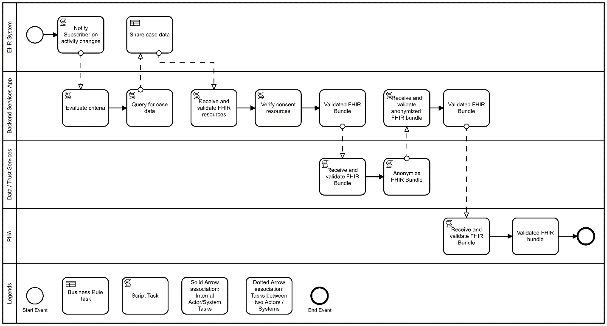
Figure 6. Hepatitis C Reporting Activity Diagram

Reporting Sequence Diagram
Figure 7 below represents the interactions between actors in the sequential order that they occur in the Hepatitis C reporting workflow.
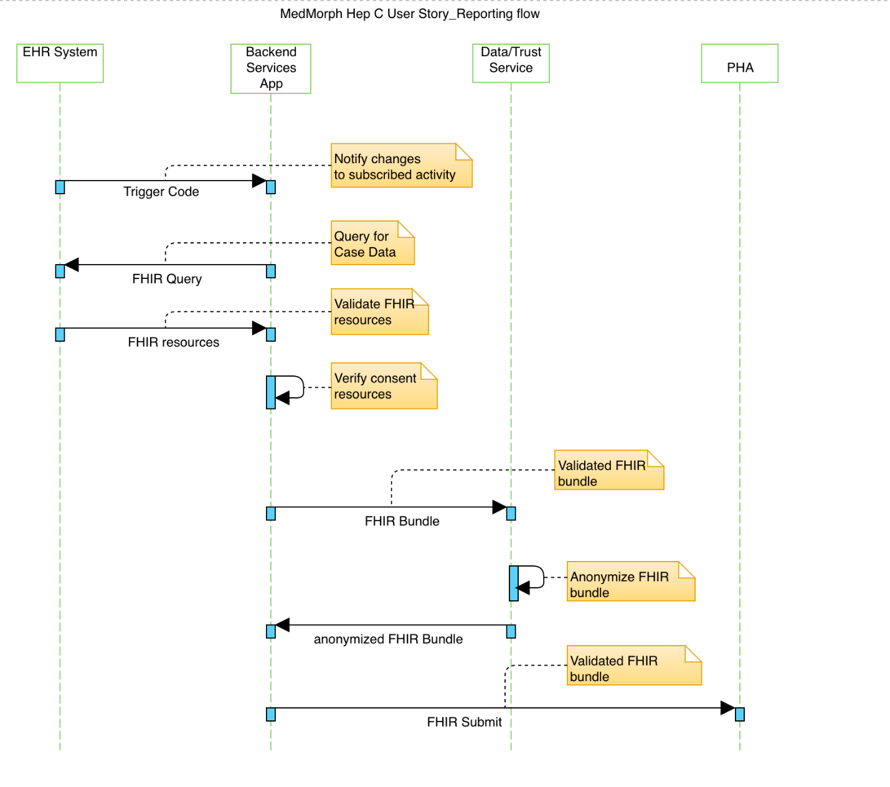
Figure 7. Hepatitis C Reporting Sequence Diagram

Postconditions
Postconditions describe the state of the system, from a technical perspective, that will result after the execution of the operation, process activity or task.

Postconditions for the hepatitis c use case include:
- A hepatitis C case report and longitudinal case information resides in a registry.

Alternate Flow(s)
The Hepatitis C use case has identified flows that include alternate pathways for the exchange of hepatitis c data which include:
- Convey care cascade elements to clinical registries and HIEs to support population health management activities by healthcare providers and payer
- Transfer HCV data elements for research, augmented surveillance, and population health management

Data Requirements
The table below includes the data requirements for the Hepatitis C use case based on the abstract model and the use case flows.

A link to the detailed data requirements spreadsheet will be provided.

Data Element Name | Definition | Sample Values | USCDI | USCDI Element
HCV Test |  | Anti-HCV, HCV RNA, HCV genotype | Laboratory | Tests
Hepatitis C Diagnosis |  | Acute, Chronic | Problems | n/a
HCV Treatment |  | Prescribed direct acting antiviral (DAA) | Assessment and Plan of Treatment?
HCV Cure (SVR) | Negative HCV RNA level 6 months after starting treatment |  | Laboratory | Values/ Results
Pregnancy Status* | If pregnant, infants of HBV or HCV infected women should be tested for infection (see disease specific guidelines) | HCG result positive | n/a
Last Menstrual Period |  |  | n/a
Pregnancy Outcome |  |  | n/a
Gestational Age at Outcome |  |  | n/a
Infant Born with Neonatal Abstinence Syndrome (NAS) |  |  | Problems | n/a
Injected Drug Use (ever) |  |  | n/a
Current Drug Use |  |  | n/a
SUD/OUD Diagnosis |  |  | Problems | n/a
MAT Prescribed |  |  | n/a
MAT Administered | RxNorm or NDC codes |  | Medication
Patient Name |  |  | Patient Demographics | First Name  Last Name
Patient Address |  |  | Patient Demographics | Current Address
Patient Age | Core variables (NEDSS standards) |  | n/a
Patient Sex | Core variables (NEDSS standards) |  | Patient Demographics | Birth Sex
Patient Race | Core variables (NEDSS standards) |  | Patient Demographics | Race
Patient Ethnicity | Core variables (NEDSS standards) |  | Patient Demographics | Ethnicity
Origin of report* | Site requesting viral hepatitis testing |  | n/a
State of report* | Core variables (NEDSS standards) |  | n/a
County of report* | Core variables (NEDSS standards) |  | n/a
Zip code of report* | Core variables (NEDSS standards) |  | n/a
Date of birth* | Core variables (NEDSS standards) |  | Patient Demographics | Date of Birth
Date of illness onset* | First sign or symptom of hepatitis |  | Problems | n/a
Presence of symptoms of acute hepatitis* | Verifies case definition |  | Problems | n/a
Presence of jaundice* | Verifies case definition |  | Problems | n/a
ALT level* | Verifies case definition |  | Laboratory | Values/ Results
Hospitalization for hepatitis* | If yes, verify dates of hospitalization |  | n/a
Hospitalization for hepatitis dates* |  |  | n/a
Death from hepatitis* | If yes, review death certificate and medical records to rule out other potential causes of death and to confirm acute liver failure as cause of death |  | n/a
IgM anti-HAV* | Verifies case definition. Determine all results (positive and negative). |  | Laboratory | Values/ Results
HBsAg* | HBsAg positive test results require confirmation by an additional more specific assay  Verifies case definition. Determine all results (positive and negative). |  | Laboratory | Values/ Results
IgM anti-HBc* | Verifies case definition. Determine all results (positive and negative). |  | Laboratory | Values/ Results
anti-HCV* | anti-HCV positive test results require confirmation by an additional more specific assay or for anti-HCV, a S/CO ratio ≥3.8.  Verifies case definition. Determine all results (positive and negative). |  | Laboratory | Values/ Results
anti-HDV* | Verifies case definition. Determine all results (positive and negative). |  | Laboratory | Values/ Results
Date of diagnosis* | Date of test result confirming infection |  | Problems | n/a
Table 3. Hepatitis C Data Elements

Policy Considerations
The policy considerations for the use case to be implemented in the real-world include:
Coming soon…

Non-Technical Considerations
The non-technical considerations for the use case to be implemented in the real-world include:
Coming soon…

Appendices
- Related Use Cases and Links
- References to Appropriate Documentation
- Terms and Definitions
- electronic Case Reporting (eCR): The automated generation and electronic submission of reportable diseases and conditions from an electronic health record (EHR) to public health agencies
- Direct Acting Antiviral (DAA) Therapy: Medications targeted at specific steps within the HCV life cycle
- Hepatitis C Virus (HCV): Causes Hepatitis C.
- HCV Care Cascade: Includes a series of necessary and inter-linked steps including the following: HCV screening by antibody testing, HCV confirmation with HCV RNA testing, linkage to HCV care, retention in care, prescription of HCV therapy, adherence to treatment, and finally achievement of SVR.
- HCV Antibody Test: Determines infection of the hepatitis C virus (HCV). The hepatitis C antibody test looks for antibodies that the body produces in response to the presence of HCV.
- HCV RNA Test: A blood test used to diagnose hepatitis C and measure the levels of virus in the bloodstream.
- Hepatitis C: Hepatitis C is a liver infection caused by the hepatitis C virus. Hepatitis C can range from a mild illness lasting a few weeks to a serious, lifelong illness. Hepatitis C is often described as “acute,” meaning a new infection or “chronic,” meaning lifelong infection.
  - Acute hepatitis C occurs within the first 6 months after someone is exposed to the hepatitis C virus. Hepatitis C can be a short-term illness, but for most people, acute infection leads to chronic infection.
  - Chronic hepatitis C can be a lifelong infection with the hepatitis C virus if left untreated. Left untreated, chronic hepatitis C can cause serious health problems, including liver damage, cirrhosis (scarring of the liver), liver cancer, and even death.
- Nucleic Acid Test (NAT): a technique used to detect a particular nucleic acid sequence and thus usually to detect and identify a particular species or subspecies of organism, often a virus or bacteria that acts as a pathogen in blood, tissue, urine, etc.
- Use Case: Document used to capture user (actor) point of view while describing functional requirements of the system. They describe the step by step process a user goes through to complete that goal using a software system. A Use Case is a description of the ways an end-user wants to "use" a system. Use Cases capture ways the user and system can interact that result in the user achieving the goal. (adapted from https://www.visual-paradigm.com/)
- User Story: A User Story is a note that captures what a user does or needs to do as part of his/her work. Each User Story consists of a short description written from user's point of view, with natural language. (adapted from: https://www.visual-paradigm.com/)

- Topics for Technical Work Groups
- Clinical Workflows/Business Processes/Data Flows:
  - Closed/Completed Encounter - what term should be used as the trigger event?
  - When a prescription is made that triggers a report—this is a clinical workflow issue -Does doc enter prescription, but then it sits in limbo until PA received and script is filled? If so, report may be triggered weeks before treatment is initiated. Or is prescription not actually sent until after PA received (so gap is minimal). And, of course, clinical registries serving closed systems might actually have access to the pharmacy fill data, and so prefer to trigger based on patient pick up (vs. prescription sent). Then again, would those pharmacy data be captured in the EHR? Or would they be a separate feed to the registry (like direct lab reporting is to public health)?
    - Are we seeing any movement towards sharing data between pharmacies and providers, such that a “pick up” (vs. “prescribed) trigger is worth considering? Perhaps as part of a trigger hierarchy that says 1. Rx pick up within X days of order, else 2. Rx order?
- Unassigned:
  - What assumptions are we making an EHR registration of an APP and what does it entail on what is being pushed back to the App
    - We are looking at FHIR subscription models and provisioning of Trigger codes
    - Work through this with the App orchard
  - A comment regarding lossiness, provenance, etc. was raised but it was determined that the topic could be secondary goal of the MedMorph project and doesn’t belong in a use case document - but more of a technical artifact. A concise bullet point was provided “Ensure integrity of shared data, including formatting and metadata (e.g., about provenance) as possible while enabling comparability and adherence to standards.”
    - Original topics: Preserve source data (persist the source data in original format) / Minimize the transformation of data / be aware and accommodate for lossiness / preserve provenance and semantics of the source data / be aware of/accommodate for missingness/incompleteness of data? A person's records are scattered all over different health systems.

https://www.cdc.gov/surveillance/projects/bridging-public-health-and-health-care-better-exchange-better-data.html
http://nationalacademies.org/hmd/Reports/2016/Eliminating-the-Public-Health-Problem-of-Hepatitis-B-and-C-in-the-US.aspx
https://www.hcvguidelines.org/evaluate/testing-and-linkage
https://www.hcvguidelines.org/evaluate/testing-and-linkage
https://www.healthit.gov/isa/representing-patient-pregnancy-status
Adapted from: https://www.healthit.gov/faq/what-electronic-health-record-ehr
An asterisk indicates data element came from: https://www.cdc.gov/hepatitis/statistics/surveillanceguidelines.htm

