MedMorph Cancer Use Case

Description <Describe the objective of the use case.>
The purpose of the use case is to transmit cancer case information to state Central Cancer Registries. The intent is to provide access to data not currently available, or available through non-standard and/or manual methods; it will not replace hospital registry reporting methods that are working well. The cancer use case will help assess how to address the gaps in workflow and triggers, and the potential to leverage existing HL7 FHIR Implementation Guides to address the public health information needs.

Problem Statement <What is the challenge/problem the use case is attempting to address?>
Cancer is a mandatory reportable disease; every state has public health law/regulation requiring information to be reported about all cancers diagnosed or treated within that state. However, even with reporting requirements, cancer surveillance is complex given the heterogeneous nature of the disease, numerous diagnostic and prognostic factors, and multiple medical encounters that produce data from a variety of non-harmonized data sources.

Challenges include:
- issues with data flow
- delays in data availability
- a lack of standardized systems for cancer data collection and reporting (in some cases)

These challenges make it difficult for registries to synthesize information in a timely and actionable way.

Goals of the Use Case<List of objectives to ensure use case meets the need.>
The goal of this use case is to identify missed cases of cancer reporting and provide incidence data faster for research and public health. Additionally, this use case aims to identify data standards that allow for the collection, transmission, and aggregation of these data electronically from EHRs automatically rather than relying on labor intensive manual processes, and duplications of effort.

User Stories <One or more user stories that can be observed in the real-world including actors, events, systems, trigger events and actions.>

User Story #1
A patient with a dark skin ulcer on her arm visits a dermatologist. The dermatologist performs a biopsy that is sent to the pathology laboratory for testing. The laboratory analyzes the biopsy specimen which indicates the patient has melanoma in situ. The pathology report is sent to the dermatologist who performed the biopsy. The dermatologist confirms the diagnosis of melanoma in situ. This information is integrated into the patient's clinical record. The patient is informed of her test results. The dermatologist’s EHR system determines that the patient has been diagnosed with a cancer that meets the criteria for reporting to the central cancer registry, as defined by the national standard Cancer Reportability List. A standard report with the required data elements is sent to the central cancer registry where the patient resides, as required by state law.

User Story #2
The medical oncologist sends his patient to the cancer treatment center to initiate the chemotherapy regimen as the first course of treatment for her colon cancer. The chemotherapy drugs are infused, and the chemotherapy treatment is documented in the EHR as the reason for the encounter/visit.
The EHR system determines that the patient was seen for treatment of a cancer meets the criteria for reporting to the central cancer registry, as defined by the national standard Cancer Reportability List. A standard report with the required data elements is sent to the central cancer registry where the patient resides, as required by state law.
The patient returns to the cancer treatment center to receive the next chemotherapy cycle. The intravenous chemotherapy drugs are infused, and the chemotherapy treatment is documented in the EHR as the reason for the encounter/visit.
The EHR system determines that the patient was seen for treatment of a cancer meets the criteria for reporting to the central cancer registry, as defined by the national standard Cancer Reportability List. A standard report with the required data elements is sent to the central cancer registry where the patient resides, as required by state law.

Scope of the Use Case <Identifies the scope for the use case.>

In-Scope <What we will accomplish and do with this use case.>
- Collect standardized data on all types of reportable cancers diagnosed

- Define when a cancer report must be created and transmitted to the central cancer registry
- Identify the data elements to be retrieved from the EHR to produce the cancer report
  - Use NAACCR Volume II data dictionary for standardized data collection

Out-of-Scope <What the use case will not cover or will not attempt to solve.>

- Integrating claims data into the trigger event to send report to the cancer registries
- Validation of the EHR data
- Querying HIEs

Use Case Actors <List of actors and the definition of those actors related to the use case.>
- EHR System: Conforms to the electronic health record (EHR) definition in Appendix X of this document. The EHR System in this use case has the requisite FHIR APIs available.
- FHIR Server / Reporting App: Interacts with the EHR to determine the trigger rules and subscribes to the EHR for topics. The App will interact with the EHR, gather the appropriate data, and then transmit the data to the appropriate systems.
- Central Cancer Registry System: A system with a FHIR API that receives and stores cancer case information.

Use Case Abstract Model <Visual diagram with actors, activity, and systems involved in the workflows.>

Paragraph to define what the model is showing and what it means

Use Case Flow and Diagrams <Chronological steps of interactions among actors to include the activity undertaken by the actor the inputs and outputs. This includes the Main, Precondition, Postcondition, Alternate flows.>

Preconditions <Conditions that must exist for the use case to start. These conditions describe the state of the system, from a technical perspective, that must be true before an operation, process, activity or task can be executed. It lists what needs to be in place before executing the use case flow.>

- EHR and Central Cancer Registry systems support HL7 FHIR APIs

- A cancer diagnosis has been recorded in the EHR

- Provisioning? (obtaining and refreshing)

Main Flow < Main Flow is the most common way in which the use case is executed.>

Step | Actor | Role | Activity | Input(s) | Output(s)
1 | EHR System | Data Collection | Determine codes exist to meet the cancer reportability criteria | Completed Record | Matching trigger code
2 | EHR System | Notifier | Notify the Backend App that criteria have been met | Trigger code | Notification message
3 | Backend App | Data Extractor | Query the EHR for cancer data | Notification message | FHIR query
4 | EHR System | Query Responder | Return cancer data | FHIR query | FHIR bundle
5 | Backend App | Data Receiver | Receive and validate FHIR bundle | FHIR bundle | FHIR validated bundle
6 | Backend App | Data Sender | Send validated FHIR bundle to Central Cancer Registry | FHIR validated bundle | FHIR validated bundle
7 | Central Cancer Registry System | Data Receiver | Receive and validate FHIR bundle | FHIR bundle | Validated FHIR bundle

Postconditions <Describes the state of the system, from a technical perspective, that will result after the execution of the operation, process activity or task.>
- The submitted cancer report is present at the registry.

Alternate Flow < Alternate Flows present a new pathway for the information exchange (e.g., capture error messages returned if the data are unavailable or not permitted to be shared).>
- None at this time

Use Case Diagram <Illustrates the actors and systems interactions.>
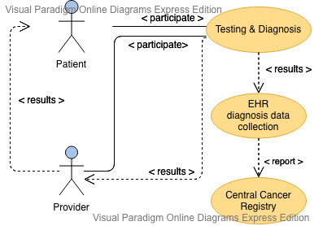

Activity Diagram <Illustrates the flow of events and information between the Actors.>

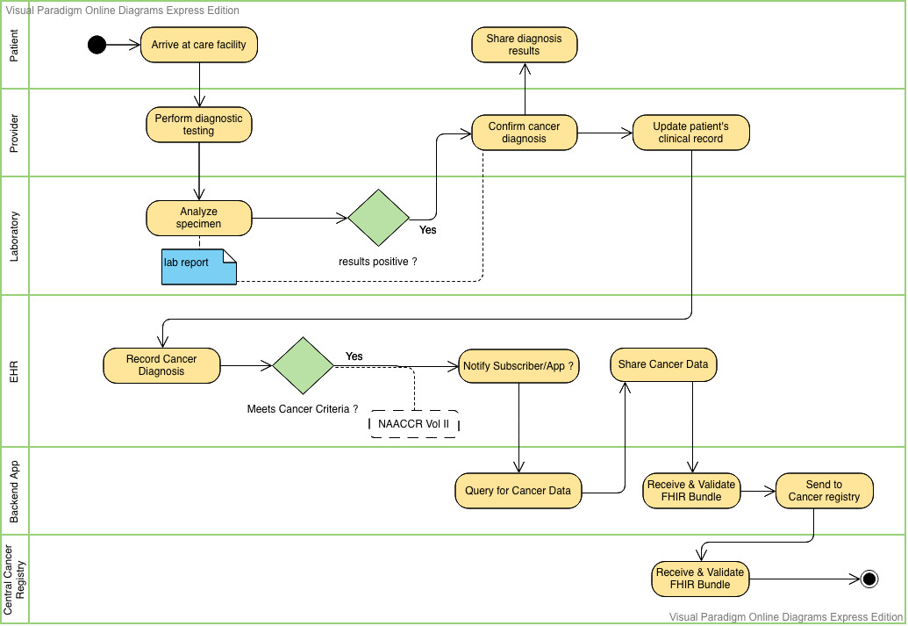

Sequence Diagram <Represents the interactions between objects in the sequential order that they occur in the User Story.>

Data Requirements <Identify the data requirements for the use case based on the abstract model and the use case flows.>

A link to the detailed data requirements spreadsheet will be provided.

Cancer Data Elements: Note that these are pulled from NAACCR Version 18 Data Standards and Data Dictionary (Click the link for detailed information regarding each element).
Data Element Name | Definition | Sample Values | Availability (Always, Maybe, Never) | Source (Manual Entry, API, Transform, PH Investigation)
Demographics
Name--Last
Name--Suffix
Name—First
Name--Middle
Name--Maiden
Name--Alias
Addr Current--No & Street
Addr Current--Supplementl
Addr Current--City
Addr Current--State
Addr Current—Postal Code
Addr Current--Country
Telephone
Address at Diagnosis--No & Street
Addr at Dx--Supplementl
Addr at Dx--City
Addr at Dx--State
Addr at Dx--Postal Code
Addr at Dx--Country
countyAtDxGeocode2010
Sex
Date of Birth
Social Security Number
Medicare Beneficiary Identifier
Race 1
Race 2
Race 3
Race 4
Race 5
Spanish/Hispanic Origin
Birthplace--State
Birthplace--Country
Marital Status at DX
Census Occ Code 2010 CDC
Census Ind Code 2010 CDC
Facility Specific Information
Primary Payer at DX
Medical Record Number
Reporting Source
Physician--Managing (Code--Registry may use physicians’ medical license numbers or may create individual numbering systems.)
Physician--Follow-Up
Physician 3
Physician 4
NPI--Physician--Managing
NPI--Physician--Follow-Up
NPI--Physician 3
NPI--Physician 4
Reporting Facility (i.e., FIN number)
(CoC code for the facility whose data are described in the record.)
NPI--Reporting Facility
Date of First Contact
Date of Last Contact
Cancer Diagnosis and Stage
Date of Diagnosis
Histologic Type ICD-O-3
Behavior Code ICD-O-3
Clinical Grade
Pathologic Grade
Post Treatment Grade
Diagnostic Confirmation
Primary Site
Laterality
Schema ID
AJCC ID
TNM Edition Number
TNM Clin Staged By
TNM Clin Stage Group
TNM Clin T
TNM Clin N
TNM Clin M
TNM Path Stage Group
TNM Path T
TNM Path N
TNM Path M
SEER Summary Stage 2000
SEER Summary Stage 2018
Medical
Secondary Diagnoses 1-10
Site Specific Items
Site Specific Data Item (SSDI)
Treatment
RX Hosp--Surg Prim Site
RX Summ--Surg Prim Site
RX Date Surgery
RX Date Mst Defn Srg
Phase I Radiation Treatment Modality
RX Date Radiation
RX Hosp--Chemo
RX Summ--Chemo
RX Date Chemo
RX Text--Chemo
RX Hosp--Hormone
RX Summ--Hormone
RX Date Hormone
RX Text--Hormone
RX Hosp--BRM
RX Summ--BRM
RX Date BRM
RX Text—Other
RX Hosp—Other
RX Summ—Other
RX Date Other
RX Text--Other
Follow-up
Institution Referred To
NPI--Inst Referred To
Institution Referred From
NPI--Inst Referred From
Text
Text--Usual Occupation
Text--Usual Industry
Text--DX Proc--PE
Text Place of Diagnosis
Text--DX Proc--Path
RX Text--Radiation (Beam)
RX Text--Radiation (Other)
Text--Staging
Text--DX Proc--X-ray/Scan
Text--DX Proc--Scopes
Text--DX Proc--Lab Tests

Policy Considerations <Capture policy considerations for the use case to be implemented in the real-world such as authorities, data use agreements, etc.>

Non-Technical Considerations <Capture non-technical considerations for the use case to be implemented in the real-world such as performance, SLAs etc.>

- Should we only use diagnosis codes, or expand to include others such as procedures?
- Should we use specific histology/morphology codes, such as those used in pathology reports?
- Will we consider reporting guidelines, such as certain data content that should be reported under certain specific circumstances (e.g., based on cancer type, stage, treatment)?
- Do we care about complications, etc. related to the cancer?
  - Need input from registries on this – currently this is not captured in the cancer report

Appendices
- Related Use Cases and Links
- References to appropriate documentation
- Terms and definitions
- Electronic Health Record (EHR): a real-time, patient-centered record that makes information available instantly and securely to authorized users. While an EHR contains the medical and treatment histories of patients, an EHR system is built to go beyond standard clinical data collected in a provider’s provision of care location and can be inclusive of a broader view of a patient’s care. EHRs are a vital part of health IT and can:
  - Contain a patient’s medical history, diagnoses, medications, treatment plans, immunization dates, allergies, radiology images, and laboratory and test results
  - Allow access to evidence-based tools that providers can use to make decisions about a patient’s care
  - Automate and streamline provider workflow
    - (Adapted from - Source: https://www.healthit.gov/faq/what-electronic-health-record-ehr )
- Acronyms
- Parking Lot Topics for Technical Workgroups
- Workflows or Reference Architecture:
  - Include querying data from big data platforms? What permissions are needed?
  - Standardized EHR Definition
- Workflows:
  - Triggers: reason for visit/encounter, diagnosis, problem list, pathology report
- Reference Architecture:
  - Keep track of submissions to registry so that an initial report isn’t resubmitted over and over?

