MedMorph Hepatitis C Use Case

Description <Describe the goal or objective of the use case.>
The purpose of the use case is to identify the common necessary data to support the CDS vision of eliminating viral hepatitis in the United States and worldwide by decreasing the incidence and prevalence of viral hepatitis, decreasing the morbidity and mortality from viral hepatitis, and reducing viral hepatitis-related health disparities.

Problem Statement <What is the challenge/problem the use case is attempting to address?>
Currently the data necessary for public health surveillance to determine the effectiveness of Hepatitis C treatments is difficult to get as it is stored in several disparate systems. The systems which contain treatment and cure information do not always capture the necessary data, and if the systems do capture data they may not capture or present it in a standardized way for consumption by clinical, research and public health teams.

Goals of the Use Case<List of objectives to ensure use case meets the need.>
- Complete capture/reporting of individual level data necessary to construct, monitor, and improve outcomes along the care cascade at local, regional, state, and national levels
- Access to additional clinical or social service data needed to address specific research questions or better target clinical, population health interventions

User Stories <One or more user stories that can be observed in the real-world including actors, events, systems, trigger events and actions.>
Overarching user story with each of the care cascade steps called out (can be separate user stories or one larger overarching user story with varying flavors):

USER STORY 1: Reporting priority elements of HCV surveillance and care cascade to public health

Part 1: *HCV testing (Anti-HCV HCV RNAHCV genotype)

Part 2: Hepatitis C diagnosis
- Additional flavors of the Hep C diagnosis use case:
  - Behavioral risk factors or co-morbidities (e.g., injection drug use, OUD/SUD)

Part 3: Treatment (Prescribed direct acting antiviral)
- Additional considerations/user stories associated with the “Treatment” user story
  - Initiation and adherence to MAT
  - Shifts in severity, service utilization associated with co-morbidities potentially sensitive to HCV infection (e.g., diabetes)
  - Linkage to/receipt of recommended preventive (e.g., HBV vaccination) and support (e.g., peer recovery, housing assistance) services

Part 4: Cured (SVR)? (negative HCV RNA > 3 months after completing treatment)

Supplemental 1: Convey core elements of HCV care cascade to clinical registries and HIEs to support population health management activities by healthcare providers and payers

Supplemental 2: Leverage reporting paths created under primary use case and supplemental case 1 to transfer additional data elements for research, augmented surveillance, and population health management

Scope of the Use Case <Identifies the scope for the use case.>

In-Scope <What we will accomplish and do with this use case.>
- Identify patients at risk for Hepatitis C and provide a service for providers at the point of care
- The following jurisdictional “level(s)” should be pursued for use case function development:
- Among local stakeholders
- Local -> State
- State -> National

Out-of-Scope <What the use case will not cover or will not attempt to solve.>
Example:
- How a lab test result is transmitted between lab and clinical care.
- Policies of the clinical care setting to collect consent for data sharing.

Use Case Actors <List of actors and the definition of those actors related to the use case.>

Example Actors and Definitions:
- CRN Instrument: The CRN Instrument is a form or a questionnaire that is used to collect data from patients. The instrument is designed based on data that needs to be collected using the data element definitions previously described. The CRN Instrument is also referred to as the CRN Form and CRN Questionnaire.
- CRN Instrument and Metadata Repository: The CRN Instrument and Metadata Repository is a system capable of storing the CRN Instruments along with its metadata. In addition to storing the CRN Instruments, the repository provides APIs to health IT systems to retrieve the instruments for administration. The repository may be hosted by an organization (e.g. Specific Registry) individually or can be hosted centrally by a federal agency (e.g. NIH/NLM) or a network such as Common Well or an independent organization providing CRN services.
- EHR or Other Health IT System: The EHR or Other Health IT Systems are used by providers to deliver care and can capture and store the health information about the patient. These EHR or Other Health IT systems can also be used to administer CRN Instruments to patient as part of routine care.

Use Case Abstract Model <Visual diagram with actors, activity, and systems involved in the workflows.>

Paragraph to define what the model is showing and what it means

Example Abstract Model:

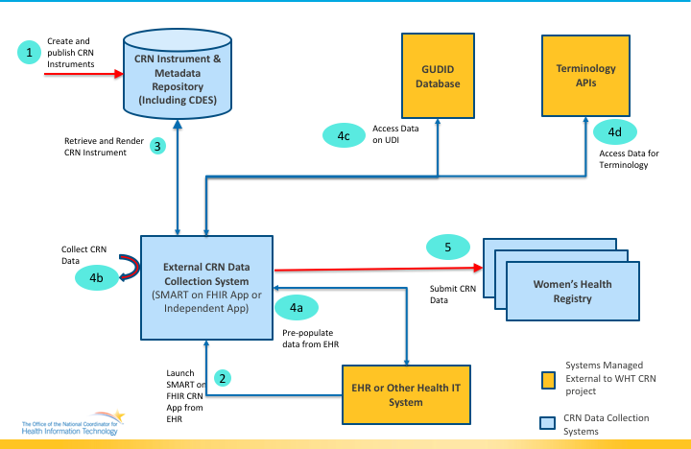

Use Case Flow and Diagrams <Chronological steps of interactions among actors to include the activity undertaken by the actor the inputs and outputs. This includes the Main, Precondition, Postcondition, Alternate flows.>

Preconditions <Conditions that must exist for the use case to start. These conditions describe the state of the system, from a technical perspective, that must be true before an operation, process, activity or task can be executed. It lists what needs to be in place before executing the use case flow.>

- Public Health uses allowed by HIPPA have been defined and implemented

Main Flow < Main Flow is the most common way in which the use case is executed.>
Example: Use Case Flow for Collecting Registry Data
Step | Actor | Role | Activity | Input(s) | Output(s)
1 | Researcher | CRN Instrument Creator | Create CRN Instrument along with its metadata and publish the instrument in the CRN Instrument and Metadata Repository | Questionnaire and associated metadata | Published CRN Instrument in the Metadata Repository
2 | Provider | Care Manager | Launch the External CRN Data Collection System (App) from within the context of an EHR or Other care delivery Health IT system. | N/A | Launched CRN instrument ready for completion by the provider
3 | CONTINUED

Postconditions <Describes the state of the system, from a technical perspective, that will result after the execution of the operation, process activity or task.>
Example:
- A completed FHIR QuestionnaireResponse is submitted to a registry.

Alternate Flow < Alternate Flows present a new pathway for the information exchange (e.g., capture error messages returned if the data are unavailable or not permitted to be shared).>
- Care Cascade Elements are conveyed to clinical registries
- Transfer HCV data elements for research, augmented surveillance, and population health management

Use Case Diagram <Illustrates the actors and systems interactions.>

Activity Diagram <Illustrates the flow of events and information between the Actors.>

Sequence Diagram <Represents the interactions between objects in the sequential order that they occur in the User Story.>

Data Requirements <Identify the data requirements for the use case based on the abstract model and the use case flows.>

A link to the detailed data requirements spreadsheet will be provided.

Hepatitis C Data Elements:
Data Element Name | Definition | Sample Values | Availability (Always, Maybe, Never) | Source (Manual Entry, API, Transform, PH Investigation)
HCV Test |  | Anti-HCV, HCV RNA, HCV genotype
Hepatitis C Diagnosis |  | Acute, Chronic
HCV Treatment |  | Prescribed direct acting antiviral (DAA)
HCV Cure (SVR) | Negative HCV RNA > 3 months after completing treatment
Pregnancy Status
Last Menstrual Period
Pregnancy Outcome
Gestational Age at Outcome
Infant Born with Neonatal Abstinence Syndrome (NAS)
Injected Drug Use (ever)
Current Drug Use
SUD/OUD Diagnosis
MAT Prescribed
MAT Administered
Patient Name
Patient Address
Patient Age
Patient Sex
Patient Race
Patient Ethnicity

Policy Considerations <Capture policy considerations for the use case to be implemented in the real-world such as authorities, data use agreements, etc.>

Non-Technical Considerations <Capture non-technical considerations for the use case to be implemented in the real-world such as performance, SLAs etc.>

Appendices
Examples:
- Related Use Cases and Links
- References to appropriate documentation
- Terms and definitions
- Acronyms

