MedMorph Hepatitis C Use Case

Description <Describe the goal or objective of the use case.>
The purpose of the use case is to identify data work flows and exchanges that can be leveraged by public health programs and stakeholders to support the nation’s vision of eliminating viral hepatitis in the United States by decreasing the incidence and prevalence of viral hepatitis, decreasing the morbidity and mortality from viral hepatitis, and reducing viral hepatitis-related health disparities. This use case will leverage and build upon current investments in electronic case reporting (eCR) efforts and extend them to meet these goals.

Case reporting to state and local Public Health Agencies for hepatitis C is required in all US states and territories. In electronic case reporting, the HL7 electronic Initial Case Report (eICR) is transmitted to the appropriate Public Health Agencies whenever certain hepatitis C diagnoses, problems, lab results, lab orders, and treatments are recorded or modified in Electronic Health Records. This use case will supplement these efforts and ensure hepatitis C surveillance and management needs are met.

Problem Statement <What is the challenge/problem the use case is attempting to address?>
Effective public health action depends on access to timely, relevant, and complete data. Unfortunately, public health access to important new sources of information—particularly, data captured in EHRs—remains limited, in part because current data systems and exchange standards are siloed, and administratively cumbersome. The public health consequences of this current state are well illustrated by—but certainly not unique to—hepatitis C surveillance. Many state and local programs do not have the data necessary to assess hepatitis C disease burden and its distribution in their communities, let alone monitor trends in key epidemiological parameters and health outcomes, like those captured in the HCV care cascade. And in the absence of such situational awareness, public health programs lack the information necessary to efficiently and effectively direct public health action and population health research activities.

Goals of the Use Case<List of objectives to ensure use case meets the need.>
- Complete capture/reporting of individual level data necessary to construct, monitor, and improve outcomes along the care cascade at local, regional, state, and national levels
- Access to additional clinical or social service data needed to address specific research questions or better target clinical, population health interventions
- Optimize access to data that already exists for public health action
- Automated reporting vs. capturing data in clinical forms (in electronic case reporting start with what is needed as identified by public health experts – data outside of that may not be found in an EHR that was being used for provision of care) – Need to determine what is core and what is not
- Core in electronic case reporting – done by requirements identified by state laws requires harmonization of initial electronic case report (eicr) – constrained IG
- HIPAA authorize – but states determine – unconsented data can be conveyed to public health if there is a companion law that requires it (which in this case are state laws)

User Stories <One or more user stories that can be observed in the real-world including actors, events, systems, trigger events and actions.>
Overarching user story with:
- “Basic” electronic surveillance / case reporting including the initiation of report by changes in recorded EHR data
- Each of the care cascade steps called out (can be separate user stories or one larger overarching user story with varying flavors):

Add some framing here:
In the care cascade there is a timing element that needs to be captured
Keep in mind trigger events and the availability of data – maybe more detailed in the use case flow but should be considered when writing the user stoy

USER STORY 1: Reporting priority elements of HCV surveillance and care cascade to public health – Overlap in eicr but need to evaluate this:
- Start with eicr and see what it covers and then determine what needs to be extended to support the care cascade
- Look at the timing and types of eCR case reports that are initiated and identify additional needs to address the care cascade

- Determine what data is available in electronic form and can be accessed (and which ones are not)

Part 1: *HCV testing (Anti-HCV HCV RNAHCV genotype) every hep c patient should have an electronic case submitted to public health enabled by state law -- dive into eicr to figure out what will be captured by the reporting and which would not

Part 2: Hepatitis C diagnosis
- Additional flavors of the Hep C diagnosis use case:
  - Behavioral risk factors or co-morbidities (e.g., injection drug use, OUD/SUD)

Part 3: Treatment (Prescribed direct acting antiviral)
- Additional considerations/user stories associated with the “Treatment” user story
  - Initiation and adherence to MAT
  - Shifts in severity, service utilization associated with co-morbidities potentially sensitive to HCV infection (e.g., diabetes)
  - Linkage to/receipt of recommended preventive (e.g., HBV vaccination) and support (e.g., peer recovery, housing assistance) services

Part 4: Cured (SVR)? (negative HCV RNA > 3 months after completing treatment)

Supplemental 1: Convey core elements of HCV care cascade to clinical registries and HIEs to support population health management activities by healthcare providers and payers

Supplemental 2: Leverage reporting paths created under primary use case and supplemental case 1 to transfer additional data elements for research, augmented surveillance, and population health management

Scope of the Use Case <Identifies the scope for the use case.>

In-Scope <What we will accomplish and do with this use case.>
- Identify patients at risk for Hepatitis C and provide a service for providers at the point of care
- The following jurisdictional “level(s)” should be pursued for use case function development:
- Among local stakeholders
- Local -> State
- State -> National

Out-of-Scope <What the use case will not cover or will not attempt to solve.>
Example:
- How a lab test result is transmitted between lab and clinical care.
- Policies of the clinical care setting to collect consent for data sharing.

Use Case Actors <List of actors and the definition of those actors related to the use case.>

Example Actors and Definitions:
- CRN Instrument: The CRN Instrument is a form or a questionnaire that is used to collect data from patients. The instrument is designed based on data that needs to be collected using the data element definitions previously described. The CRN Instrument is also referred to as the CRN Form and CRN Questionnaire.
- CRN Instrument and Metadata Repository: The CRN Instrument and Metadata Repository is a system capable of storing the CRN Instruments along with its metadata. In addition to storing the CRN Instruments, the repository provides APIs to health IT systems to retrieve the instruments for administration. The repository may be hosted by an organization (e.g. Specific Registry) individually or can be hosted centrally by a federal agency (e.g. NIH/NLM) or a network such as Common Well or an independent organization providing CRN services.
- EHR or Other Health IT System: The EHR or Other Health IT Systems are used by providers to deliver care and can capture and store the health information about the patient. These EHR or Other Health IT systems can also be used to administer CRN Instruments to patient as part of routine care.

Use Case Abstract Model <Visual diagram with actors, activity, and systems involved in the workflows.>

Paragraph to define what the model is showing and what it means

Example Abstract Model:

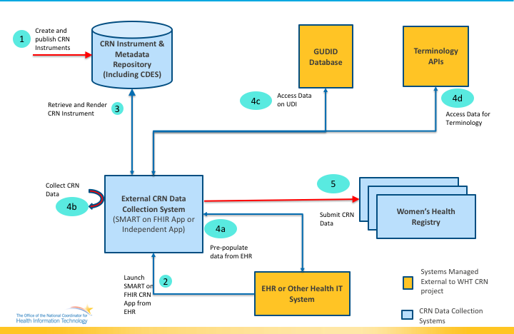

Use Case Flow and Diagrams <Chronological steps of interactions among actors to include the activity undertaken by the actor the inputs and outputs. This includes the Main, Precondition, Postcondition, Alternate flows.>

Preconditions <Conditions that must exist for the use case to start. These conditions describe the state of the system, from a technical perspective, that must be true before an operation, process, activity or task can be executed. It lists what needs to be in place before executing the use case flow.>

- Public Health uses allowed by HIPPA have been defined and implemented

Main Flow < Main Flow is the most common way in which the use case is executed.>
Example: Use Case Flow for Collecting Registry Data
Step | Actor | Role | Activity | Input(s) | Output(s)
1 | Researcher | CRN Instrument Creator | Create CRN Instrument along with its metadata and publish the instrument in the CRN Instrument and Metadata Repository | Questionnaire and associated metadata | Published CRN Instrument in the Metadata Repository
2 | Provider | Care Manager | Launch the External CRN Data Collection System (App) from within the context of an EHR or Other care delivery Health IT system. | N/A | Launched CRN instrument ready for completion by the provider
3 | CONTINUED

Postconditions <Describes the state of the system, from a technical perspective, that will result after the execution of the operation, process activity or task.>
Example:
- A completed FHIR QuestionnaireResponse is submitted to a registry.

Alternate Flow < Alternate Flows present a new pathway for the information exchange (e.g., capture error messages returned if the data are unavailable or not permitted to be shared).>
- Care Cascade Elements are conveyed to clinical registries
- Transfer HCV data elements for research, augmented surveillance, and population health management

Use Case Diagram <Illustrates the actors and systems interactions.>

Activity Diagram <Illustrates the flow of events and information between the Actors.>

Sequence Diagram <Represents the interactions between objects in the sequential order that they occur in the User Story.>

Data Requirements <Identify the data requirements for the use case based on the abstract model and the use case flows.>

A link to the detailed data requirements spreadsheet will be provided.

Hepatitis C Data Elements:
Data Element Name | Definition | Sample Values | Availability (Always, Maybe, Never) | Source (Manual Entry, API, Transform, PH Investigation)
HCV Test |  | Anti-HCV, HCV RNA, HCV genotype
Hepatitis C Diagnosis |  | Acute, Chronic
HCV Treatment |  | Prescribed direct acting antiviral (DAA)
HCV Cure (SVR) | Negative HCV RNA > 3 months after completing treatment
Pregnancy Status
Last Menstrual Period
Pregnancy Outcome
Gestational Age at Outcome
Infant Born with Neonatal Abstinence Syndrome (NAS)
Injected Drug Use (ever)
Current Drug Use
SUD/OUD Diagnosis
MAT Prescribed
MAT Administered
Patient Name
Patient Address
Patient Age
Patient Sex
Patient Race
Patient Ethnicity

Policy Considerations <Capture policy considerations for the use case to be implemented in the real-world such as authorities, data use agreements, etc.>

Non-Technical Considerations <Capture non-technical considerations for the use case to be implemented in the real-world such as performance, SLAs etc.>

Appendices
Examples:
- Related Use Cases and Links
- References to appropriate documentation
- Terms and definitions
- Acronyms

